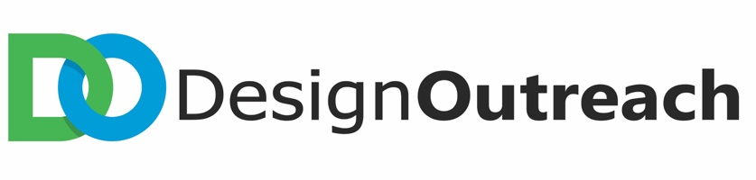

Updated May 2018
Design Outreach
Development & Administrative Assistant

Organization:
Design Outreach (DO) is a Christian humanitarian engineering nonprofit that prioritizes the needs and aspirations of the world’s poor.

Position:
Reporting to the Development Coordinator, the Development & Administrative Assistant supports fundraising efforts and manages the organization’s administrative activities. This position is part-time.

Key Responsibilities:
- Assists the Development Team with fundraising efforts, including but not limited to planning special events, creating marketing materials, and interfacing with donors.
- Collaborates with the Development Team to develop and implement fundraising and marketing strategies.
- Manages the organization’s administrative activities (i.e. data entry, report building, general office management, etc.).
- Provides support to fundraising champions and donors.
- Coordinates major fundraising events.
- Manages donor database and processes incoming donations while maintaining strict confidentiality.
- Provides additional organizational support as needed.

Requirements:
- Unqualified support of and willingness to advance Design Outreach’s vision and mission.
- The ability to work effectively with Design Outreach donors, volunteers and allied organizations.
- Friendly and energetic, possessing strong interpersonal skills.
- Self-motivated with a high capacity for being detail-oriented.
- Willingness to take the lead on new initiatives and learn new skills.
- Ability to manage multiple ongoing projects with consistent attention to detail.
- Ability to work and collaborate within a team.
- Ability to work 20 to 30 hours per week, with availability to work occasionally in the evenings and on weekends to support special events.
- Excellent verbal, written, grammar, computer, and Microsoft Office skills.
- Proficiency in database management.
- Ability to work at Design Outreach office in New Albany, Ohio.

Desired:
- Bachelor’s degree in applicable field
- Marketing and communications experience
- Familiarity with nonprofits
- Fundraising experience
- Knowledge working in Excel, Salesforce, Mailchimp, and Wordpress
- References

Timeline:
- Position start date is immediate, and interviews will be ongoing until filled.
- Please send cover letter and resume to Operations Director Lara Lambert at laral@doutreach.org.

